**GAS LEAKAGE MONITORING AND ALERTING**

**SYSTEM**

Submitted by

**TEAM LEAD: T.VIKRAM (622519106053)**

**TEAM MEMBERS: S.BARATH (622519106007)**

**V.NAVEEN KUMAR (622519106025)**

**M.NITHESH (622519106027)**

In partial fulfilment of award of the degree

Of

**BACHELOR OF ENGINEERING**

**IN**

**ELECTRONICS AND COMMUNICATION**

**ENGINEERING**

**1.INTRODUCTION**:

**1.1 PROJECT OVERVIEW**:

One of the very important things in human life is safety. Safety refers to the awareness of risks and potential dangers in and around human locations, which may cause bodily harm or even death. There are several kinds of risks and potential dangers which threaten the safety of many houses and lives. One of the risks and potential dangers is the gas leak that may affect serious damage in the place where the person is. [1] Liquefied Petroleum Gas (LPG) was first discovered in 1910 by the scientist Dr. Walter Snelling which is a mixture of commercial gases such as propane and butane with saturated and unsaturated hydrocarbons Due to the usefulness of LPG, it is widely employed for many purposes such as industrial and domestic fuel, auto gas, heating, lighting, etc. The wide demand for LPG leakage is growing day by day. However, when LPG is leaked, it may cause serious fire accidents. Also, the number of casualties due to such incidents is also on the rise in recent years. Therefore, there is the purpose for a system to find and also prevent the leakage of LPG. Before the invention of electronic gas detectors for households in the 1980s, they were detected by a chemical dipped paper that changed its color in the presence of those gases. But then, many inventions were discovered to find, monitor, and alert the spillage of dangerous gases [2]. LPG consists of a mixture of propane and butane which is a highly flammable chemical. It is an odorless gas due to which Ethanethoil is added as a powerful odorant, so that leakage can be easily detected. LPG Gas leaks have increased from 0.72% to 10.74% of all kitchen accidents. The small LPG cylinder of weight 5kg in which the burner is located immediately over the cylinder without using a rubber tube is seen to be safer than the one which uses a rubber pipe as this subway has the hazards of getting cracked which in turn can make way to leakage [3]. In this research, a computer program running online was created to detect leakage locations and act as an automatic supervisor in remote areas; simple gas leak detector is a simple device that is used to detect the leakage of gas and if the gas leak occurs, an equivalent message is conveyed by the means of a buzzer and powered by Wi-Fi, it is capable to broadcast messages to the stakeholders about the LPG leak through the cloud which is based on the IoT technology; where -IoT is defined as a system that permits the devices for communicating with each other directly without human intervention [4]-. The proposed system will continuously monitor the environment for any leakage. Just in case of any leakage detection, it'll alert the user via a buzzer and by using the ESP2866 wifi microcontroller and an IOT platform ; it'll alert the user about the environmental conditions to the gas level of that location of IBM cloud (as mentioned previously) notification.

**1.2 PURPOSE:**

Gas or liquefied petroleum gas (LPG) is a chemical substance resultant from petroleum and could be dangerous in industrial places or those that deal with this substance. Gas leakage causes many health issues. So, to prevent such catastrophes and in order to maintain a clean air environment, the workspace atmosphere should be frequently monitored and controlled. The proposed monitoring gas leakage detector system is based on Internet of Things (IoT) technology. NodeMCU ESP8266 Wi-Fi is used to be the microcontroller for the whole system. The combustible gas sensor (MQ6) is used in order to detect the presence of propane,Butane and LPG. MQ6 sensor will detect the concentration of the gas according to the voltage output of the sensor and the ESP8266 will send the data reading from the gas sensor to IBM IoT platform over the network. Besides, a fan will immediately work upon the leakage occurs along with an alarming buzzer.

**KEYWORDS: Gas leakage, IBM Cloud platform, LPG, Alarm system.**

**2.LITERATURE SURVEY:**

* 1. **EXIXTING PROBLEM:**

In this existing system which include some safety factors. A safety has been a major issue in today’s day to day life. LPG and CNG i.e.petroleum gas and compressed natural gas are most commonly used in residential and commercial places for cooking purpose and in various vehicles as a replacement for costly fuels like diesel, petrol . These gases are filled in cylinders which are easily un-damageable. But leakage can take place through pipes or regulators or knobs which may cause accidents like suffocation, uneasiness or sometimes.The existing system in gas leakage detection is done using microcontroller.This system contains only few application like gas leakage detection and producing an alarm signal whenever gas leakage is detected

* 1. **REFERENCES:**

[1].[Shruthi Unnikrishnan](https://ieeexplore.ieee.org/author/37086341640) et al proposed “LPG monitoring and leakage detection system“IEEE TRANSACTIONS ON INFORMATION FORENSICS AND SECURITY – 2018.

The existing system for the leakage detection considering the various hazards due to explosion of LPG. But as the demand for LPG increased, the scarcity of LPG started to become a common phenomenon. Hence it paved the way for research around the implementation of systems that monitor the level of LPG in a cylinder instantaneously [5]. The above research and talks with eminent engineers from various industries laid the foundation for gathering information about the proposed system. system is an effective combination of these features which are manufactured in a cost effective way.

# [2]. [Ravi Hosur](https://ieeexplore.ieee.org/author/37086765224) et al proposed “A Survey on Automatic Detection of LPG Gas Leakage “IEEE TRANSACTIONS ON INFORMATION FORENSICS AND SECURITY – 2019.

This method to identify and solve the fire accidents by different agents by producing the products like Smoke detectors, fire alarms, fire extinguishers and sprinklers etc. these devices are just going to identify the leakage of gas and alert/stop the catch of fire, and failing prevents fire accidents which is a major disadvantage. So, some the techniques which are developed are surveyed and presented in the next section.

# [3]. [Brij Bansh Nath Anchal](https://ieeexplore.ieee.org/author/37086578569) et al proposed “(UPCON) Fabrication of electro-spin coated Zn0.97 Fe0.03O nano-rough thin film and application in LPG sensing *Spin coated thin film using in LPG detection

# “IEEE TRANSACTIONS ON INFORMATION FORENSICS AND SECURITY – 2019.

This paper report to 100 ppm, 300 ppm, 500 ppm LPG detection using Zn0.97Fe0.03O nano rough thin film at 50 oC. This operating temperature choosen because these are near about room temperature and maximum temperature in summer approximate is 50 oC. The LPG lower explosive limit (LEL) is 2% [8, 9]. So LPG sensing research below 1% volume concentration for safety purpose [8]. So leakage of LPG is needs to detection in the lowest concentration because this concentration increased then cause of accidental event. It major used in cooking.

# [4]. [Mon Arjay F. Malbog](https://ieeexplore.ieee.org/author/37088422680) et al proposed LPG Leakage and Flame Detection with SMS Notification and Alarm System: Rule-Based Method

# “IEEE TRANSACTIONS ON INFORMATION FORENSICS AND SECURITY – 2020.

In this research developed an LPG Leakage and Flame Detection system with SMS Notification and Alarm System to ensure the safety and security of consumers using LPG. The unit can detect gas, smoke, and flames from the LPG tank, and can alert the owner using a rule-based approach via text messages. The device may also display a warning note, and use a buzzer to alert the owner. One paper focus on image processing can be apply to this system and some use object detection with segmentation.

# [5]. [Ramya.K. C](https://ieeexplore.ieee.org/author/37088925778) et al proposed LPG Leakage Detector with Smart SMS Alert using Microcontroller“IEEE TRANSACTIONS ON INFORMATION FORENSICS AND SECURITY – 2021

In this method the GSM module will be used to alert a person by SMS and a buzzer will be on simultaneously. It will show the SMS to the specified portable number using Microcontroller. If a gas exceeds normal level, then an immediate alarm is generated with the help of MQ-6 sensor, it is highly accurate and has high sensitivity towards LPG gas. It bids rapid response time and accurate detection.

**2.3 PROBLEM STATEMENT DEFINITION:**

# Liquid Petroleum Gas (LPG) is a highly flammable chemical that consists of mixture of propane and butane. LPG is used for cooking at home, restaurant, and certain use for industry. They have certain weaknesses that make the gas leakage occur. The leakage of gases only can be detected by human nearby and if there are no human nearby, it cannot be detected. But sometimes it cannot be detected by human that has a low sense of smell. Thus, this system will help to detect the presence of gas leakage.Furthermore, gas leakage can cause fire that will lead to serious injury or death and it also can destroy human properties. This system was developed by using IoT to give real-time response to the user and the nearest fire station.

* To build a system that can detect the liquid petroleum gas leakage.
* To detect the changes of temperature caused by fire.
* To send the information to the nearest fire station through Internet of Thing (IoT).

**3.IDEATION & PROPOSED SOLUTION:**

**3.1 EMPATHY MAP CANVAS**

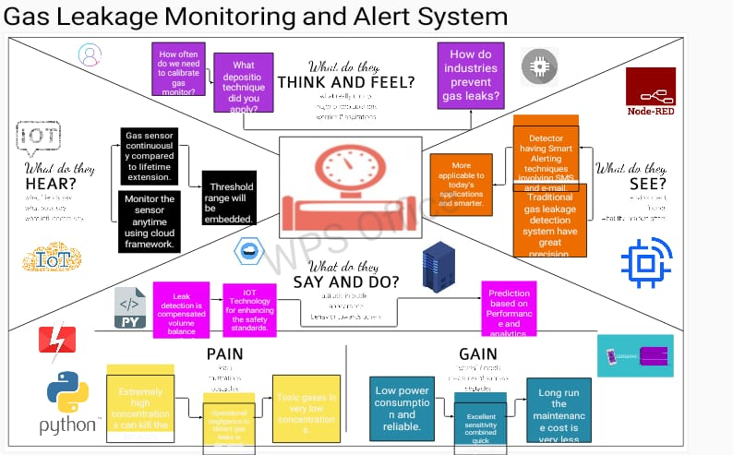

**3.2 IDEATION & BRAINSTORMING:**

Traditional gas leakage detection system have great precision.

More applicable to today's applications and smarter.

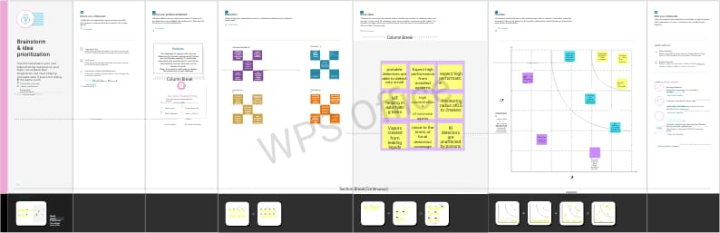

**3.3 PROPOSED SOLUTION:**

In this proposed system LPG gas detection using IOT method. The first source is a power Supply T09D060-2D1, which is a transformer that converts high voltage 220v to low voltage 9v and feeds the fan. The second source is a battery rechargeable (3.3v-5v) that feeds the controller (Wi-Fi Node MCU ESP8266) as well as the rest of the circuit elements.

In this research, the hardware components (Gas Sensor MQ-6, Wi-Fi Node MCU ESP8266, Fan, Power Supply 9V, Buzzer, Relay, Battery 3.3v to 5v, Transistor B514, Breadboard, 200 ohms resistors) were used along with IBM cloud .

This paper approaches a simplified and effective device for detecting and monitoring LPG detection. This device can be used in any place where LPG is used. A NodeMCU development board is used as a controller. MQ6 gas sensor are used for LPG detection. The sensor data are uploaded on a IBM cloud. Users can access this data from anywhere if he has internet access or without internet within the NodeMCU wifi range free at cost. This system can send automated SMS to the concerned authority if LPG leakage is detected. The system also triggers a buzzer alarm to aware of the people. A combination of a web server monitoring and SMS alarming subsystems made this low-cost device unique and more effective rather than other existing devices. This simplified device is portable and can be implemented in house and industrial.sector for monitoring LPG. This system contains two power source.

**3.4 PROBLEM SOLUTION FIT**

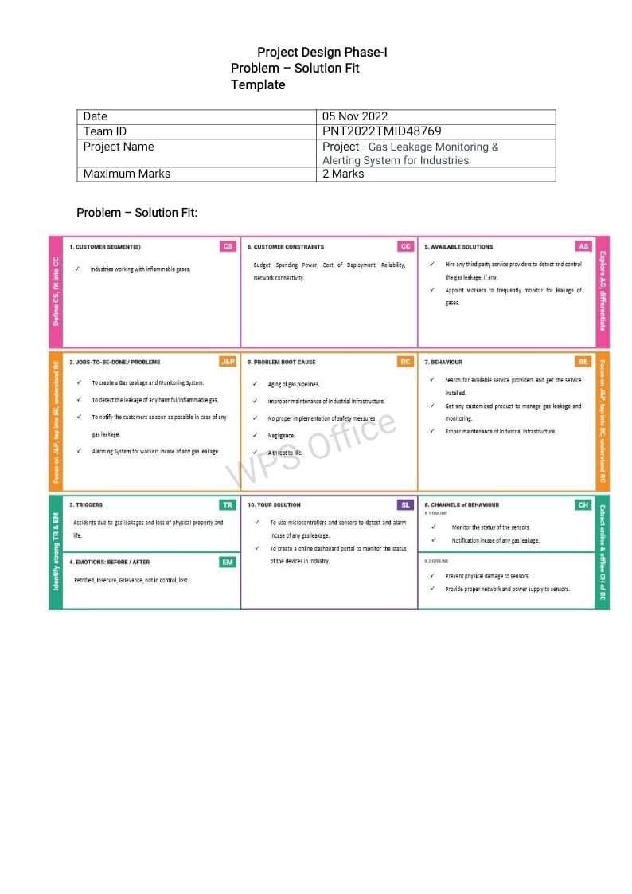

**4. REQUIREMENT ANALYSIS:**

**4.1 FUNCTIONAL REQUIREMENT:**

Gas sensors (also known as gas detectors) are electronic devices that detect and identify different types of gasses. They are commonly used to detect toxic or explosive gasses and measure gas concentration. Gas leakage can introduce risk of fire, which can occur inside homes, commercial premises or factories. Since the LPG does not have any odour. Gas companies add an odorant such as Esthanethiol, Thiophene or Mercaptan so human can detect the leakage by the sense of smell.Gas sensor will detect the presence of the LPG gas sensor in a room. The voltage value will then be converted into digital data by ADC on the microcontroller. Then the obtained data will be processed by the microcontroller and the results will be processed by the microcontroller and the results will be displayed on the LCD.A funor its component. A functional requirements defines a system of LPG gas detection and discharging of Internet of Things(IoT).

**HARDWARE REQUIREMENTS**:

* Node MCU(ESP 8266)
* Buzzer
* Gas sensor
* Driver
* Relay
* Enhanst Fan

A function (otherwise known as a procedure or sub-routine) is a named piece of code that can be used from elsewhere in a sketch. For example, here's the definition of the setup() function from the Blink example:

void **setup**()  
{  
   pinMode(ledPin, OUTPUT);         
}

The first line provides information about the function, like its name, "setup". The text before and after the name specify its return type and parameters: these will be explained later. The code between the { and } is called the body of the function: what the function does.

### pinMode(), digitalWrite(), and delay()

The pinMode() function configures a pin as either an input or an output. To use it, you pass it the number of the pin to configure and the constant INPUT or OUTPUT. When configured as an input, a pin can detect the state of a sensor like a pushbutton; As an output, it can drive an actuator like an LED.

The digitalWrite() functions outputs a value on a pin.

For example, the line:

digitalWrite(ledPin, HIGH);

The delay() causes the Arduino to wait for the specified number of milliseconds before continuing on to the next line. There are 1000 milliseconds in a second, so the line:

delay(1000);

**setup() and loop()**

There are two special functions that are a part of every Arduino sketch: setup() and loop(). The setup() is called once, when the sketch starts. It's a good place to do setup tasks like setting pin modes or initializing libraries. The loop() function is called over and over and is heart of most sketches. You need to include both functions in your sketch, even if you don't need them for anything.

Everything between the /* and */ is ignored by the Arduino when it runs the sketch (the * at the start of each line is only there to make the comment look pretty, and isn't required). It's there for people reading the code: to explain what the program does, how it works, or why it's written the way it is. It's a good practice to comment your sketches, and to keep the comments up-to-date when you modify the code. This helps other people to learn from or modify your code.

**4.2 NON-FUNCTIONAL REQUIREMENTS:**

A non-functional requirement defines the quality attributes of a software system.It specifies “What should the software system do?” it places constraines on “How should the software system fulfil the functional requirements?”.In system engineering and requirements engineering a non functional requireements us a requireemnts that specifies criteria that can be used to judge the operation of a system, rather than specific behaviours. They are constrasted with non-functional requirements that define specific behaviour or functions. The pklan for implementing functional requirements is detailed in the system desigh. The plan for implementing functional requirements is detailed in the system architecture, because they are usually architecturally siginificant of non-functional requirements.

**SOFTWARE REQUIREMENTS:**

* Arduino IDE
* Microcontroller
* Power supply unit

It consists of microcontroller (PIC 16F877A), gas sensor, weight sensor (Load Cell- L6D), GSM module (SIMCOM 300), and display(s). To monitor the LPG, **an efficient and fast working microcontroller** is required. The microcontroller also controls the working of the gas sensor and load sensor output.

**5 PROJECT DESIGN:**

**5.1 DATA FLOW DIAGRAMS:**

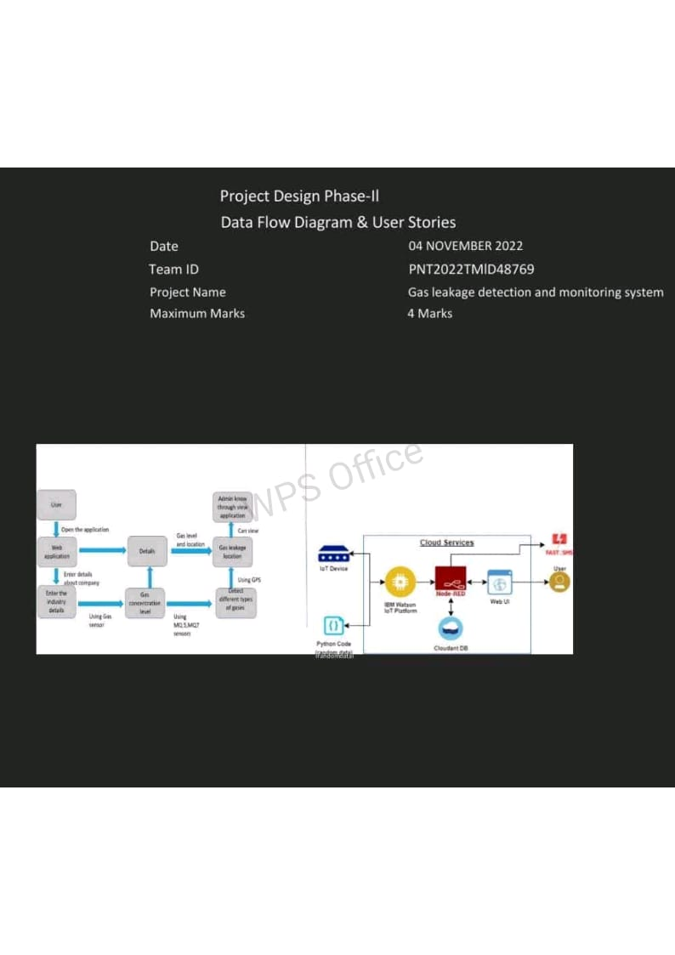

**5.2 SOLUTION & TECHNICAL ARCHITECTURE:**

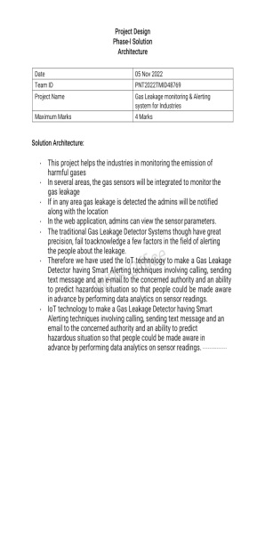

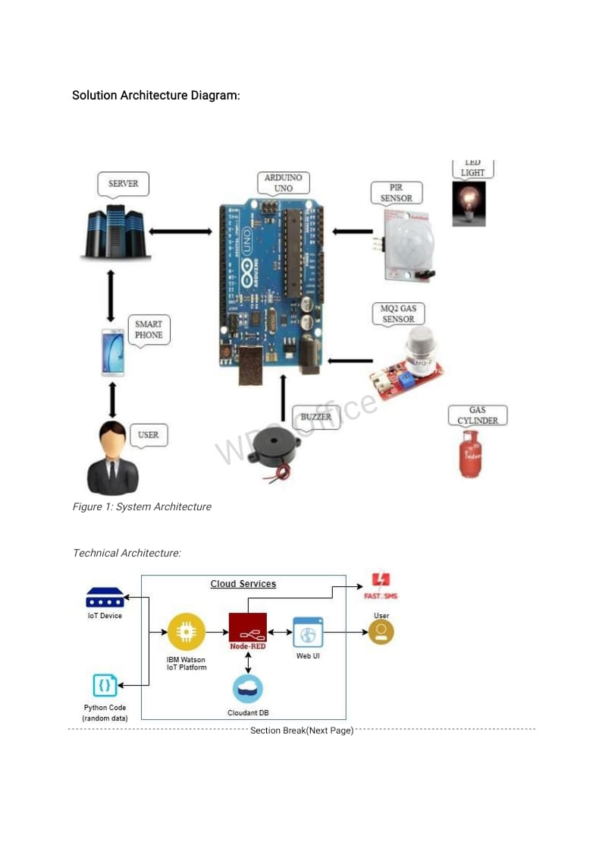



**5.3 USER STORIES:**

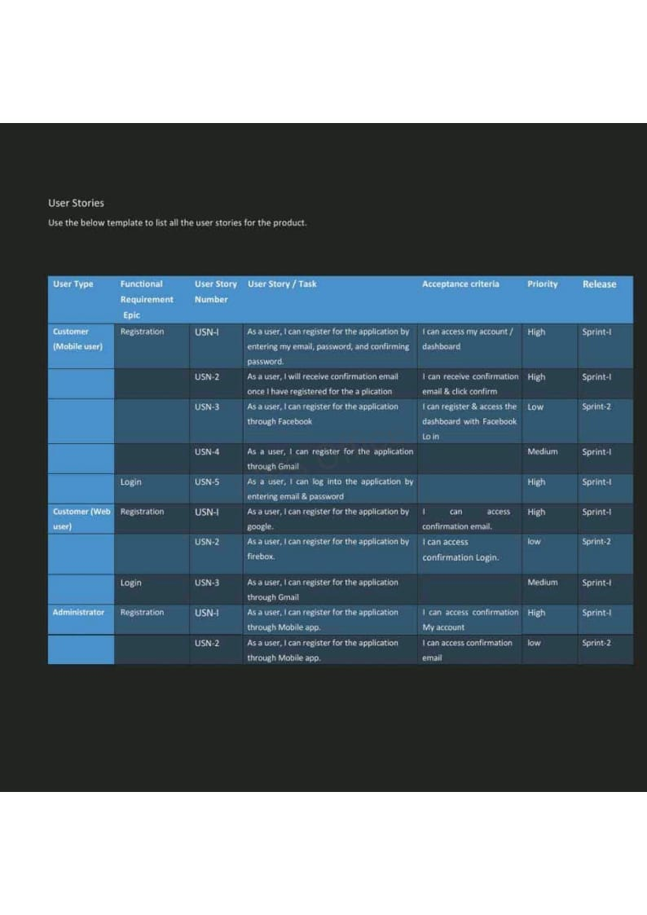

**6 PROJECT PLANNING:**

**6.1 SPRINT PLANNING & ESTIMATION:**

**6.2SPRINT DELIVERY SCHEDULE:**

**6.3 REPORT FROM JIRA:**

The circuit for an LPG leakage detector is readily available in the market, but it is extremely expensive and usually based on a [microcontroller](https://www.electronicsforu.com/microcontroller-projects-ideas) (MCU). Presented here is a low-cost circuit for an LPG detector that you can build easily.The main objective of the circuit is to detect LPG leakage anywhere.

Circuit and Working of the LPG leakage detector:

Circuit diagram of the low-cost LPG detector is shown in Fig. 2. It is built around step-down transformer X1, two rectifier diodes [1N4007](https://www.diodes.com/assets/Datasheets/ds28002.pdf) (D1 and D2), a 1000µF capacitor (C1), [7805](https://www.electronicsforu.com/resources/learn-electronics/7805-ic-voltage-regulator) voltage regulator (IC1), MQ-6 LPG gas sensor (GS1), dual comparator LM393 (IC2), darlington transistor TIP122 (T2), 12V high-gain siren/buzzer (PZ1) and a few other compon

**7 CODING & SOLUTIONING:**

**7.1 FEATURE:1**

import RPi.GPIO as GPIO

import time

import urllib2

import json

GPIO.setmode(GPIO.BCM)

GPIO.setwarnings(False)

GPIO.setup(26, GPIO.IN)

#GPIO.setup(3, GPIO.OUT)

def sendNotification(token, channel, message):

data = {

"body" : message,

"message_type" : "text/plain"

}

req = urllib2.Request('http://api.pushetta.com/api/pushes/{0}/'.format(channel))

req.add_header('Content-Type', 'application/json')

req.add_header('Authorization', 'Token {0}'.format(token))

response = urllib2.urlopen(req, json.dumps(data))

while True:

i=GPIO.input(26)

if i==0: #When output from LPG sensor is LOW

print("No Gas Leakage D…

**7.2 FEATURE:2**

include "LiquidCrystal.h"

LiquidCrystal lcd(9,8,7,6,5,4);

int GAS_VAL = 0;

void setup()

{

pinMode(A0, INPUT); // MQ-6 A0 Pin

Serial.begin(9600);

lcd.begin(16,2);

pinMode(11,OUTPUT); // LED Green

pinMode(12,OUTPUT); // LED Red

lcd.setCursor(0,0);

lcd.print(" GAS SENSOR ");

}

void loop()

{

GAS_VAL = analogRead(A0);

Serial.println(GAS_VAL);

if (GAS_VAL > 500)

{

lcd.setCursor(0,1);

lcd.print(" LPG Detected ");

digitalWrite(11,HIGH);

digitalWrite(12,LOW);

}

else

{

lcd.setCursor(0,1);

lcd.print("LPG Not Detected ");

digitalWrite(11,LOW);

digitalWrite(12,HIGH);

}

delay(10);

}

**7.3 DATABASE SCHEME**

Today, India has around 16.64 crore active consumers of Liquefied Petroleum Gas (LPG). Around 21 million tonnes of LPG is required for consumption per annum. This deimport RPi.GPIO as GPIO

Listed below are the schemes provided for the benefit of LPG consumers.As per this scheme, BPL families can receive a new LPG connection without having to pay the security deposit for a cylinder and a pressure regulator. However, they are required to bear the following expenses,

* Installation or demonstration charges for the new connection.
* Administrative charges and cost of DGCC.
* Cost of gas stove and LPG rubber tube at the time of release of new LPG connection.
* If the stove is not procured from the LPG distributer, it needs to be inspected. These inspection charges will be borne by the customer.
* Price of LPG in the new cylinder.

All these charges should be paid to the concerned distributor.Every cylinder that is used by a consumer carries a subsidy of around Rs. 200. This amounts to a huge subsidy burden that deters the government from utilising these resources in other developmental activities. In an attempt to focus the LPG subsidy towards the needy, the government has launched the 'Opt out of subsidy' scheme. As per this scheme, the government motivates LPG consumers who can afford to pay the market price for LPG to surrender their subsidy.

Customers can opt-out from LPG subsidy through the website, www.mylpg.in or by submitting Form-5 to their distributors.

This scheme is targeted at streamlining the possession and transfer of LPG connections.

* For connection transfers, a written consent is needed from the registered customer for transfer to the person holding the equipment and SV.
* The distributor verifies the submitted documents and settles the security deposit amount between the registered customer and holder of the equipment.
* A fresh SV will be issued to the holder of the equipment.
* For people holding equipment without any connecting documents, a security deposit at the prevailing rate is charged.
* In case of death of the SV holder, the beneficiary shall be transferred the connection on submitting Death Certificate and Legal Heir Certificate/NOC.
* Transfer of LPG connection within the family is possible if the registered member provides a written consent for the same.

PSU Oil Marketing Companies act as Principals and take Insurance policies for LPG accidents including Third Party Insurance Cover. These are Public Liability Policies and are not in the name of an individual customer.

* The distributor does not collect any premium for the insurance policies from the customer.
* The claim amount is remitted through the Oil Company to the beneficiary.
* There are limits on the liability for compensation.

Under this provision, a customer can shift to an alternate distributor if he/she is dissatisfied with service. This is useful in keeping distributors competent and in providing improved service to customers.

* Customers can transfer the connection through the website, [www.mylpg.in](http://www.mylpg.in).
* The approval of the parent distributor is not needed to initiate transfer. The customer can complete required documentation at the new distributorship within the specified time.
* There shall be no transfer fee or additional security deposit for transfer of LPG connection under this scheme.
* There is a commendable electronic tracking mechanism to ensure smooth processing of the transfer request. The initial phase of the PAHAL scheme required the consumer to have  to avail LPG subsidy. This has been reviewed comprehensively and a modified scheme has been launched recently. Once a customer joins the scheme and is ready to receive subsidy in his bank account, he is said to be Cash Transfer Compliant (CTC).
* As per the modified approach, there are two methods by which LPG customers can receive subsidy.
  + Primary option - Aadhaar will remain the medium of cash transfer. The Aadhaar number is linked to the bank account and the LPG consumer number.
  + Secondary option - If the LPG consumer does not have an Aadhaar number, he can receive subsidy in his bank account irrespective of this. In this case, the consumer is required to produce his bank account information to the LPG distributor for updating the LPG database. He should also present his LPG consumer ID to his bank.
* If LPG consumers were already CTC prior to the update in PAHAL, they need not take fresh action to receive subsidy.
* As per this scheme, LPG cylinders will be sold to customers at Market Determined Price.
* Customers who join PAHAL will be provided a one-time advance, and it will remain with the customer till termination of connection. At termination, the amount will be adjusted by the distributor.

**8 TESTING:**

**8.1 TEST CASES:**

The higher the LPG gas is detected, the higher the voltage released. When the sensor output is moved The presence of gas, then Arduino will activate, and activate the buzzer and display the writing on the LCD stating the gas is high (high), which means there has been a gas leak, then the GSM SIM800L module will send a notification message to the handphone number specified in the program. However, if the sensor does not detect a leak, the sensor will not remove the output, and the sensor will continue to work until it is proven that there is an LPG gas leak. The system design in this study is described in the form of a flowchart to facilitate the reading and understanding of the system that will be made in this study. When the program is run the system will immediately detect LPG gas detected by the sensor. Then the Arduino microcontroller will read LPG gas through an LPG gas sensor. If it detects a gas leak, the red LED will light up, the buzzer will activate, then the system will send a notification message stating that there has been an LPG gas leak. If no LPG gas leak is detected, the system will continue to detect the gas level through the LPG gas sensor until it detects an LPG gas leak. System flow. The way the system works and this tool is, first when the system is turned on and this tool will immediately detect the gas content, using a sensor that is designed to be able to detect LPG gas, namely the MQ-2 gas sensor. Then each LPG gas level detected by the sensor is directly processed or converted into an analog signal. Then the analog signal will be sent directly by the MQ-2 sensor to Arduino. Because the analog signal to be sent is a number of LPG gas levels detected by the MQ-2 sensor. Then this analog signal will later become the Arduino working parameter. Does the gas level exceed the limit or not. If the level of LPG received by Arduino exceeds the predetermined limit of 5000ppm (part per million), then the Arduino will directly control the other connected ones, namely relay, buzzer, and SIM800L, by sending commands to the relay to turn on the LED (Light Emitting Diode) red which indicates danger. Then Arduino sends commands to control the buzzer to be active, to give an alarm signal as a marker in the form of sirens that there has been a leak of LPG gas that has exceeded a predetermined limit. Finally, Arduino will instruct the SIM800L module to send an SMS message to the owner, to provide information about leaked LPG gas. However, if the gas content in the form of an analog signal received by the Arduino from the MQ-2 gas sensor does not exceed the limit of 5000ppm, then Arduino will not control other components. Or in other words, the system and this tool will work normally as when the initial system was turned on, which is detecting the existing level of LPG gas. Why in this case did the author make the gas parameter limit leak at the level of 5000 ppm? Because based on the MQ-2 gas sensor technical data, the range that can be measured by the MQ-2 gas sensor against LPG type gas ranges from 200ppm to 5000ppm. Therefore, in this case, the authors set a maximum limit of the level of LPG gas leakage at 5000ppm.

**8.2 USER ACCEPTANCE TESTING:**

Power supplies for electronic devices can be broadly divided into linear and switching power supplies. The linear supply is a relatively simple design that becomes increasingly bulky and heavy for high current devices; voltage regulation in a linear supply can result in low efficiency. A switched-mode supply of the same rating as a linear supply will be smaller, is usually more efficient, but will be more complex.

**Linear Power supply:**

An AC powered linear power supply usually uses a transformer to convert the voltage from the wall outlet (mains) to a different, usually a lower voltage. If it is used to produce DC, a rectifier is used. A capacitor is used to smooth the pulsating current from the rectifier. Some small periodic deviations from smooth direct current will remain, which is known as ripple. These pulsations occur at a frequency related to the AC power frequency (for example, a multiple of 50 or 60 Hz).

The voltage produced by an unregulated power supply will vary depending on the load and on variations in the AC supply voltage. For critical electronics applications a linear regulator will be used to stabilize and adjust the voltage. This regulator will also greatly reduce the ripple and noise in the output direct current. Linear regulators often provide current limiting, protecting the power supply and attached circuit from over current.

Adjustable linear power supplies are common laboratory and service shop test equipment, allowing the output voltage to be set over a wide range. For example, a bench power supply used by circuit designers may be adjustable up to 30 volts and up to 5 amperes output. Some can be driven by an external signal, for example, for applications requiring a pulsed output.

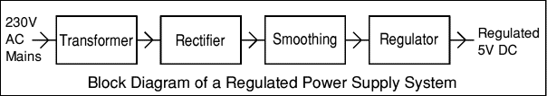

### Transformer:

### transformer symbol

The input coil is called the primary and the output coil is called the secondary. There is no electrical connection between the two coils; instead they are linked by an alternating magnetic field created in the soft-iron core of the transformer. The two lines in the middle of the circuit symbol represent the core. The ratio of the number of turns on each coil, called the turn’s ratio, determines the ratio of the voltages. A step-down transformer has a large number of turns on its primary (input) coil which is connected to the high voltage mains supply, and a small number of turns on its secondary (output) coil to give a low output voltage.

Turns ratio=Vp/Vs=Nn/Ns and Power out=Power in

Vs*Is=Vp * Ip

|  |  |  |
| --- | --- | --- |
| Vp = primary (input) voltage Np = number of turns on primary coil Ip  = primary (input) current |  | Vs = secondary (output) voltage Ns = number of turns on secondary coil Is  = secondary (output) current |

### The varying DC output is suitable for lamps, heaters and standard motors. It is not suitable for electronic circuits unless they include a smoothing capacitor. Power supplies for electronic devices can be broadly divided into linear and switching power supplies. The linear supply is a relatively simple design that becomes increasingly bulky and heavy for high current devices; voltage regulation in a linear supply can result in low efficiency. A switched-mode supply of the same rating as a linear supply will be smaller, is usually more efficient, but will be more complex.

**Linear Power supply:**

An AC powered linear power supply usually uses a transformer to convert the voltage from the wall outlet (mains) to a different, usually a lower voltage. If it is used to produce DC, a rectifier is used. A capacitor is used to smooth the pulsating current from the rectifier. Some small periodic deviations from smooth direct current will remain, which is known as ripple. These pulsations occur at a frequency related to the AC power frequency (for example, a multiple of 50 or 60 Hz).The voltage produced by an unregulated power supply will vary depending on the load and on variations in the AC supply voltage. For critical electronics applications a linear regulator will be used to stabilize and adjust the voltage. This regulator will also greatly reduce the ripple and noise in the output direct current. Linear regulators often provide current limiting, protecting the power supply and attached circuit from over current.Adjustable linear power supplies are common laboratory and service shop test equipment, allowing the output voltage to be set over a wide range. For example, a bench power supply used by circuit designers may be adjustable up to 30 volts and up to 5 amperes output. Some can be driven by an external signal, for example, for applications requiring a pulsed output.



The input coil is called the primary and the output coil is called the secondary. There is no electrical connection between the two coils; instead they are linked by an alternating magnetic field created in the soft-iron core of the transformer. The two lines in the middle of the circuit symbol represent the core. The ratio of the number of turns on each coil, called the turn’s ratio, determines the ratio of the voltages. A step-down transformer has a large number of turns on its primary (input) coil which is connected to the high voltage mains supply, and a small number of turns on its secondary (output) coil to give a low output voltage.

Turns ratio=Vp/Vs=Nn/Ns and Power out=Power in

Vs*Is=Vp * Ip

|  |  |  |
| --- | --- | --- |
| Vp = primary (input) voltage Np = number of turns on primary coil Ip  = primary (input) current |  | Vs = secondary (output) voltage Ns = number of turns on secondary coil Is  = secondary (output) current |

### AC power supply, transformer only

### DC power supply, transformer + rectifier

The varying DC output is suitable for lamps, heaters and standard motors. It is not suitable for electronic circuits unless they include a smoothing capacitor.

### Operation of a Bridge Rectifier

presence of gases is a necessity to conduct industrial operations as several pitmen had lost their lives due to lack of oxygen in the process of mining explorations. A sudden decrease in the oxygen levels can result in dizziness, brain damage, or even death among the workers working in mines or close-packed industrial premises. A gas monitoring system significantly benefits the industries by maintaining proper oxygen levels that reflect the optimal performance of your workers. This system also creates alerts in real-time about the decreasing oxygen levels, which gives enough time to take necessary measures to evacuate the facilities much before the health gets affected.

c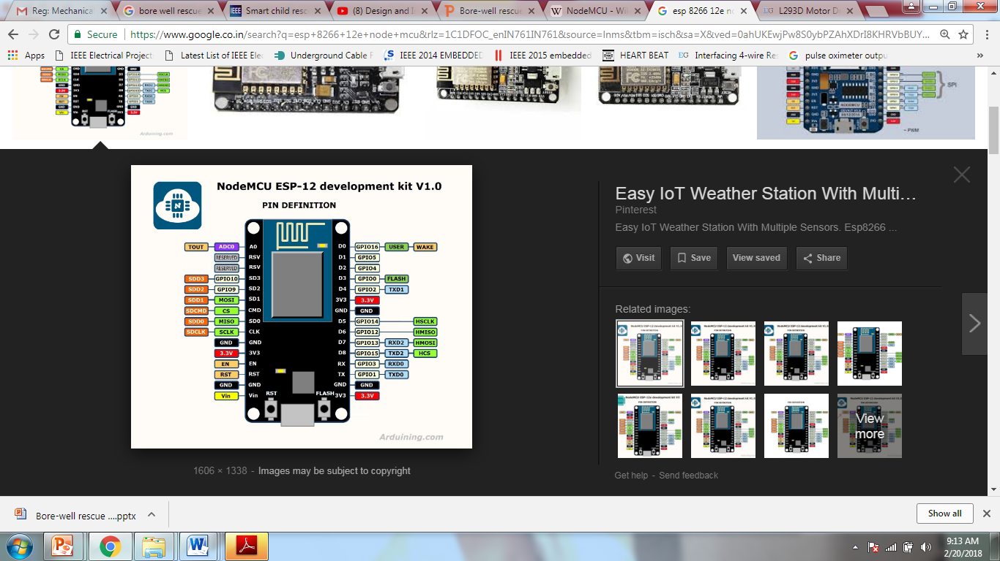

**9.RESULTS:**

**9.1 PERFORMANCE METRICS:**

The result of this project is determined by using a lighter to collect leaked gas around the gas sensor,after sensing procedure if sensor value is greater than the threshold value then ESP 8266(NODE MCU) will perform its programmed tasks : Immediately turn off the regulator knob to stop further leakage. After detecting the gas leakage, the relay will be on the Enhanst fan to prevent any further accidents. Buzzer starts beeping to alert the nearby people. The exhaust fan will fan out all enclosed gas from the environment. The wi-fi module updates the information to the cloud. The user can get to know the gas values and status of the system through the app and also control of the power supply can be done manually by the user through the app.

**10.ADVANTAGES AND DISADVANTAGES:**

**ADVANTAGES:**

They are most commonly used to develop an IoT-powered system and identify the variation of toxic gasses in an industrial facility. It helps benefit the refineries and factories by safeguarding them from unexpected threats such as gas leakage and explosions. Here are the top benefits of IoT-based apps used in gas leakage detection.

* Get real-time alerts about the gaseous presence in the atmosphere
* Prevent fire hazards and explosions
* Supervise gas concentration levels
* Ensure worker’s health
* Real-time updates about leakages
* Cost-effective installation
* Data analytics for improved decisions
* Measure oxygen level accuracy
* Get immediate gas leak alerts

**APPLICATIONS:**

**Harmful Gas Detection:**

The sensing of toxic gases such as H2S, Methane, and CO is of great importance in any industry to avoid unwanted leakage and consequences like poisoning or explosions. The presence of these gases can be easily detected in the industrial facilities and commercial buildings with the help of IoT-powered gas monitoring solution. Moreover, a gas detector or sensor device is a crucial part to carry out safe industrial operations. The sensor-enabled solution helps prevent the high risk of gas explosions and affecting any casualties within and outside the premises.

**DISADVANTAGES:**

**It gets reacted due to heating of wire**. ➨It measures toxic gases in very low concentrations. ➨It has ability to detect wide range of gases. ➨It is difficult to know failure modes unless very advanced methods of monitoring are used.

* It causes suffocation, in case of leakage as it heavier than air.
* It is hazardous as it inflammable gas.
* It is consumed more as it has low energy density.
* It does not provide power to the vehicle in mountains or rough terrains.
* It is costlier than CNG.

**11.CONCLUSION:**

This paper aimed at monitoring and detection system to meet the safety standards and to avoid free accidents due to the leakage. The system detects gas int the atmosphere and will be continuously update and display the gas value, the value can be seen by the user through the mobile app easily.This system provides a quick response rate and the diffusion of the critical situation can be made faster than the manual methods. The system alerts and responds quickly in case of leakage with help of alerting and by sending SMS to concerned authority.

**12.FUTURE SCOPE:**

Another major future scope could be including a Automatic Shut-off device which will turn off the gas supply whenever it will detect any gas leakage. This system can be implemented in Industries, Hotels and wherever the LPG cylinders are used.

1) Fast Speed of response.

2) Immune to catalytic poisons.

3) High Reliability & Repeatability.

4) Heated optics eliminates condensation.

5) Ability to operate in the absence of oxygen or in enriched oxygen

As detectors measure a specified gas concentration, the sensor response serves as the reference point or scale. When the sensors response surpasses a certain pre-set level, an alarm will activate to warn the user. There are various types of detectors available and the majority serves the same function: to monitor and warn of a dangerous gas level. However, when considering what type of detector to install, it is helpful to consider the different sensor technologies.

Gas Detector Technologies :- Gas detectors are categorized by the type of gas they detect: combustible or toxic. Within this broad categorization, they are further defined by the technology they use: catalytic and infrared sensors detect combustible gases and electrochemical and metal oxide semiconductor technologies generally detect toxic gases.

Measurement of Combustible Gases :-

Catalytic sensors represent a large number of gas detector devices that are manufactured today. This technology is used to detect combustible gases such as hydrocarbon, and works via catalytic oxidation. The sensors of this type of detector are typically constructed from a platinum treated wire coil. As a combustible gas comes into contact with the catalytic surface, it is oxidized and the wiring resistance is changed by heat that is released. A bridge circuit is typically used to indicate the resistance change.

Infrared sensors or IR detectors work via a system of transmitters and receivers to detect combustible gases, specifically hydrocarbon vapors. Typically, the transmitters are light sources and receivers are light detectors. If a gas is present in the optical path, it will interfere with the power of the light transmission between the transmitter and receiver. The altered state of light determines if and what type of gas is present.

Common Gas Detector Applications

Although detectors are an essential application for home and commercial safety, they are also employed in numerous industrial industries. Gas detectors are used in welding shops to detect combustibles and toxics and in nuclear plants, to detect combustibles. They are also commonly used to detect hazardous vapours in wastewater treatment plants.

Gas detectors are very efficient in confined spaces where there is no continuous employee occupancy. Such spaces include tanks, pits, vessels and storage bins. Detectors may also be placed at a site to detect toxins prior to occupant entry.

The chemical industry is a major player in the global economy.

Leak Detection:

Leaks are an ever-present hazard even in the best run chemical plants. Depending on the severity of the leak and the gas involved, the effects can potentially be very serious both within and without the perimeter of the plant. An explosion or fire will damage plant and put workers at risk, while toxic gases can spread rapidly, also putting the public at risk. Even a minor small leak has an economic impact on the plant's profitability as material is being wasted and the fault has to be rectified. To monitor for leaks, fixed gas detectors are integrated into the plant at key weak points such as valves, joints and pumps. The sensors used will obviously depend on the nature of the gas to be detected. For flammable gases, pellistors are widely used. This sensor works by burning the target gas; the heat generated producing a change in the resistance of the detecting element of the sensor proportional to the gas concentration. To detect hydrocarbons, NDIR sensors are widely used. Ultrasonic gas leak detectors measure the ultrasonic sound level, typically between 25 kHz to 10 MHz frequencies. Ultrasonic gas detectors are mainly used for outdoor environments where weather conditions can easily dissipate escaping gas before allowing it to reach gas leak detectors that require contact with the gas in order to detect it. These detectors are most useful in facilities with a lot of outdoor pipeline.

**13 APPENDIX:**

The gas sensors help detect the concentration of the gases present in the atmosphere to avoid hazardous consequences like fire breakouts. Also, it is an imperative solution to keep the plant workers and equipment safe from fire hazards. It effectively detects the presence of hazardous gases like propane and methane and alerts the plant authorities, preventing the premises from unexpected ignition. Moreover, a gas monitoring solution uses gas analyzers to generate alerts regarding the temperature increase. This allows the management to take immediate actions to curb harmful fire explosions.Sensing the presence of gases is a necessity to conduct industrial operations as several pitmen had lost their lives due to lack of oxygen in the process of mining explorations. A sudden decrease in the oxygen levels can result in dizziness, brain damage, or even death among the workers working in mines or close-packed industrial premises. A gas monitoring system significantly benefits the industries by maintaining proper oxygen levels that reflect the optimal performance of your workers. This system also creates alerts in real-time about the decreasing oxygen levels, which gives enough time to take necessary measures to evacuate the facilities much before the health gets affected.